# DESIGN AND DEVELOPMENT OF A MULTIFUNCTIONAL HANDHELD THERAPEUTIC INSTRUMENT

A project report submitted in partial

fulfilment of the requirements for the degree of

Bachelor of Technology

In

Electronics & Computer Engineering

by

ACHYUT NARAYAN H

21BLC1107



School of Electronics Engineering

Vellore Institute of Technology, Chennai,

Vandalur-Kelambakkam Road,

Chennai – 600127, India.

April 2025`



## Declaration

I hereby declare that the report titled *“Design and Development of a Multifunctional Handheld Therapeutic Instrument”* submitted by me to the School of Electronics Engineering, Vellore Institute of Technology, Chennai in partial fulfillment of the requirements for the award of **Bachelor of Technology** in **Electronics and Computer Engineering** is a bona-fied record of the work carried out by me under the supervision of ***Dr. Bala Murugan M S***.

I further declare that the work reported in this report, has not been submitted and will not be submitted, either in part or in full, for the award of any other degree or diploma of this institute or any other institute or University.

Sign: _______________________

Name & Reg. No: _______________________

Date: _______________________



##### School of Electronics Engineering

#### Certificate

This is to certify that the project report titled ***Design and Development of a Multifunctional Handheld Therapeutic Instrument*** submitted by ***Achyut Narayan H* (21BLC1107)** to Vellore Institute of Technology Chennai, in partial fulfillment of the requirement for the award of the degree of **Bachelor of Technology** in **Electronics and Computer Engineering** is a bona-fied work carried out under my supervision. The project report fulfills the requirements as per the regulations of this University and in my opinion meets the necessary standards for submission. The contents of this report have not been submitted and will not be submitted wither in or in full, for the award of any degree or diploma and the same certificate.

**Supervisor Head of the Department**

Signature: ___________________ Signature: ___________________

Name: ___________________ Name: ___________________

Date: ___________________ Date: ___________________

**Internal Examiner External Examiner**

Signature: ___________________ Signature: ___________________

Name: ___________________ Name: ___________________

Date: ___________________ Date: ___________________

Seal of the School

### Abstract

Physiotherapy techniques such as Vibration therapy, Thermotherapy and Transcutaneous Electrical Nerve Simulation (TENS are used for muscle relaxation, improved blood flow and pain relief. While vibration therapy and Thermotherapy focuses on muscles, with Vibration stimulating muscle contraction and thermotherapy helping in relaxation, TENS therapy concentrates on nerve stimulation using short electric pulses for pain relief. This requires users to purchase multiple devices for treatment as existing devices focus either on muscle-based or nerve-based therapy. Additionally, TENS units are mostly plug-in devices and therapy devices connected with an app are not widely available.

This project is about building a portable, handheld physiotherapy device that integrates Vibration therapy, Thermotherapy and TENS into single battery-powered unit. By combining both muscle-based and nerve-based therapies, this device would be an affordable and convenient solution for users. The device is prioritizing ease of operation making it suitable for individual as well as clinical use. Bluetooth connectivity enables users to configure and operate the device in various modes based on requirement using a mobile application.

### Acknowledgements

I wish to express my sincere thanks and deep sense of gratitude to my project guide Dr. Bala Marugan M S Professor, School of Electronics Engineering, for his consistent encouragement, support and valuable guidance offered to me in a pleasant manner throughout the course of the project work.

I am extremely grateful to Dr. Ravishankar A, Dean, Dr. Reena Monica, Associate Dean (Academics) & Dr. John Sahaya Rani Alex, Associate Dean (Research) of the School of Electronics Engineering, VIT Chennai, for extending the facilities of the school towards my project and for his unstinting support.

I express my thanks to Head of the Department Dr. Annis Fathima A for her support throughout the course of this project.

I also take this opportunity to thank all the faculty of the school for their support and their wisdom imparted to me throughout the course.

I thank my parents, family, and friends for bearing with me throughout the course of my project and for the opportunity they provided me in undergoing this course in such a prestigious institution.

# Contents

Declaration ii

School of Electronics Engineering iii

Certificate iii

Abstract iv

Acknowledgements v

Contents vi

List of Figures ix

List of Tables ix

Chapter 1 1

Introduction 1

Literature Survey 3

2.1 The emerging role of focal muscle vibration in rehabilitation of neurological disorders 3

2.2 Focal Vibration Therapy: Vibration Parameters of Effective Wearable Devices 3

2.3 Developing a new focal vibration and heat therapy system 3

2.4 Design and Development of Portable Transcutaneous Electrical Nerve Stimulation Device and Basic Principles for the use of TENS 4

2.5 An easy-to-build transcutaneous electrical stimulator for spinal cord stimulation therapy 4

Methodology 5

3.1 Introduction 5

3.1.1 Problem Statement 5

3.1.2 Physiotherapy 5

3.1.3 Vibration Therapy 5

3.1.4 Thermotherapy 6

3.1.5 TENS Therapy 7

3.2 System Overview 7

3.2.1 Device Design Overview 7

3.2.2 Microcontroller 8

3.2.3 Block Diagram 8

3.2.4 Bluetooth Low Energy (BLE) 8

3.2.5 ERM Vibration Motors 9

3.2.6 Heating Element 9

3.2.7 TENS Unit 10

3.2.8 Integration and Device Architecture 10

3.3 Hardware System Design 11

3.3.1 List of Components Used: 11

3.3.2 Circuit Design 12

3.4 Software Implementation 14

3.4.1 Firmware Development 15

3.4.2 Mobile Application 16

3.5 PCB Design and Fabrication 17

3.5.1 Objectives of PCB Design: 18

3.5.2 Advantages of Double Layered PCB: 18

3.6 Device Packaging 20

Results and Declaration 21

4.1 Objectives 21

4.2 System Performance and Validation 21

4.3 Constraints and Challenges 22

4.3.1 Power management 22

4.3.2 Bluetooth Connectivity and Data transfer 22

4.4 Project Timeline and Milestones 23

Conclusion and Future Work 24

5.1 Conclusion 24

5.2 Future Work 24

Appendix 26

6.1 Firmware Code 26

6.1.1 Hardware and Timer interrupt declaration 26

6.1.2 Button press and Debounce check: 26

6.1.3 Bluetooth communication Setup and data decoding 27

6.1.4 Timmer Interrupt to check device status 28

6.1.5 Device status display 29

6.2 Flutter Application Development Code 31

6.2.1 Bluetooth Setup and data encoding 31

Bibliography 33

Biodata 34

# List of Figures

Figure 1: Vibration therapy working flow diagram 6

Figure 2: Thermotherapy working flow diagram 6

Figure 3: TENS Therapy working flow diagram 7

Figure 4: System Block Diagram 8

Figure 5: Bluetooth Communication and Data transfer steps 9

Figure 6: Vibration Therapy schematic 12

Figure 7: Thermotherapy schematic 13

Figure 8: TENS Therapy schematic 13

Figure 9: Overall System Schematic 14

Figure 10: Steps of Firmware execution for device control 15

Figure 11: Mobile Application UI 17

Figure 12: Steps in PCB Design and Fabrication 18

Figure 13: PCB 1 Top Side 19

Figure 14: PCB 1 Bottom Side 19

Figure 15: PCB 2 Top Side 19

Figure 16: Steps in 3D Printing 20

Figure 17: Overall project workflow 23

Figure 18: Future device enhancement and optimisation ideas 25

# 

# List of Tables

Table 1: Individual therapy module design 11

Table 2: List of components used to build prototype 12

Table 3: Types of PCB based on layers 17

## Chapter 1

# Introduction

Physiotherapy helps in restoring, maintaining, and enhancing a patient’s well-being by employing physical techniques to treat injuries and manage pain. Among various physiotherapy methods, Vibration therapy, Thermotherapy and TENS are widely used for pain relief, muscle recovery.

* **Vibration Therapy** uses mechanical vibrations to stimulate neuromuscular system (Muscle Spindles). Helps in posture correction, increased range of motion and muscle strengthening.
* **Thermotherapy** introduces heat on the body surface to stimulate tissues by altering the core-temperature. Helps in muscle relaxation and improves blood circulation.
* **TENS Therapy** delivers low-voltage pulses into the skin and stimulates the nerves and blocks pain signals. Helps in pain relief and reducing medication use.

Despite separate devices for each therapy are available, the market lacks an all-in-one portable solution. Some devices combine muscle-based vibration therapy and thermotherapy. TENS devices are plug-in devices limiting their ease of use. This results in making the user purchase multiple devices for different therapies making it costly and inconvenient to use. Sometimes, people need to plan periodical visits to the clinic to undergo the required therapy.

The identified research gaps are as follows:

* No existing device integrates both muscle (vibration, heat) and nerve (TENS) stimulation in a single portable unit.
* There is a lack of mobile connectivity for remote therapy configuration, limiting personalized user control.
* Most devices lack true portability and do not support therapy mode customization based on individual needs.

To address these challenges, this proposed idea presents a battery-powered portable physiotherapy device that integrates vibration therapy, thermotherapy and TENS therapy into a single unit.

The proposed device is designed to address the following issues with the below mentioned solutions:

* Portable and user-friendly enabling convenient use at home and clinics
* Easy to operate by enabling Bluetooth and allowing user to control and configure via a mobile application
* Availability of customizable therapy modes
* Cost-efficient solution eliminating the need for multiple devices

By addressing all the above challenges and providing possible user-friendly and cost-effective solutions, the device aims to make physiotherapy accessible and effective for individual users of any age group as well as clinical use.

## Chapter 2

# Literature Survey

##### The emerging role of focal muscle vibration in rehabilitation of neurological disorders

This paper gives brief information about focal vibration therapy and how it is used in rehabilitation of neurological disorders. It discusses how Focal Vibration therapy delivers precise mechanical vibration to specific muscle groups, can enhance motor recovery muscle activation and neuromuscular coordination in patients with neurological conditions. This method of rehabilitation has a positive effect on the patients as it helps in long-lasting effects, increase in muscle mass, improved bone density and improved blood circulation. Different vibration frequencies are used for different purpose as follows:

* Low-frequency (30-50 Hz) therapy for muscle relaxation
* Medium frequency (80-120 Hz) therapy for pain relief and muscle relaxation
* High frequency (120-300 Hz) therapy helps in strengthening of muscle fibres

##### Focal Vibration Therapy: Vibration Parameters of Effective Wearable Devices

This paper helped understanding the standardised protocols of focal vibration therapy. This paper evaluates the characteristics of commercially available focal vibration therapy devices. This paper gives a collective idea about the available devices and the different modes (Sinusoidal, Pulse, Constant) provided by each manufacturer. Measurements of vibration frequency and intensity were taken in both constrained and unconstrained conditions. The tests conducted has shown that there are variations in vibration intensities when the device is strapped to the body surface. The test results helped in identifying effective frequency and amplitude ranges for vibration considering the variation.

##### Developing a new focal vibration and heat therapy system

This paper presents design-decision for a device to treat muscle soreness and to increase muscle strength through a combination of heat and vibration therapy.

* Vibration therapy stimulates neuromuscular responses, improving muscle activation and flexibility
* Heat therapy relaxes muscles by increasing blood flow and reducing muscle stiffness

The prototype developed was powered by a 9Volt battery. Frequency of vibration ranged between 20-170Hz. The heating pads were connected via USB with a maximum heating temperature of 50°C. Use of multiple heating pads helped in reducing the heating time.

##### Design and Development of Portable Transcutaneous Electrical Nerve Stimulation Device and Basic Principles for the use of TENS

This paper mainly discusses about developing a TENS unit which can be sued to relieve muscular pain and sprain using electrical current. A PIC microcontroller is used to generate pulses (conventional and burst mode) with the help of ADC and PWM functions to control the duty cycle.

* Conventional Mode: 50-100Hz frequency with 50-200µs pulse width
* Burst Mode: 2-4Hz frequency with longer pulse width od 100-400 µs

Device is powered with a 9 Volt battery and has option to choose between modes. This research work has helped in identifying system and component requirements for building a TENS unit. As a conclusion the research suggests that TENS is safe with no side effects. Developing TENS unit with a microcontroller makes it portable and cost-effective.

##### An easy-to-build transcutaneous electrical stimulator for spinal cord stimulation therapy

This paper discusses about the use of TENS therapy for spinal cord stimulation therapy. It gives an idea about designing a TENS unit using a microcontroller, motor driver and DC-DC convertors. Skin has high impedance, DC-DC convertors are used to step-up voltage to make it capable for pulses to penetrate skin surfaces. TENS signal is biphasic, a motor driver is used to switch the polarity of the voltage supplied by the DC-DC convertor. The frequency, amplitude and duty cycle of the generated signals are controlled by the PWM function of the microcontroller. The output pulse intensity should be controlled at maintained within safe limits of 100mA. High currents can damage skin surface.

## Chapter 3

# Methodology

##### Introduction

###### Problem Statement

Effective physiotherapy often requires multiple therapies, such as vibration therapy, heating therapy, and Transcutaneous Electrical Nerve Stimulation (TENS), to address muscle pain, stiffness, and recovery. Existing devices and solutions are often bulky, require separate devices for each therapy, lacks portability and may not provide customizable settings to suit individual needs and easier control over mobile App. Additionally, many devices fail to meet safety standards, posing risks, such as overheating or excessive current during use.

The identified gaps in the existing products are

* Lack of integration of muscle and nerve stimulation therapies into a single unit
* Lack of remote device control via mobile app
* Limited portability and usage customization
* Lack of compliance with medical standards

###### Physiotherapy

Physiotherapy, also known as physical therapy, is a health-care practice focused on diagnosing, testing and preventing physical impairments and restore physical and mental well-being of individuals. It aims to restore, maintain and enhance movement, function and overall well-being through physical approaches.

Common physiotherapy techniques include:

* Vibration therapy : Mechanical vibration to stimulate muscles
* Thermotherapy : Application of heat to improve flexibility
* Hydrotherapy : Water based exercise to reduce joint stress
* TENS therapy : Uses electrical pulses to block pain signals
* Manual Therapy : Hands-on techniques like joint mobilization

###### Vibration Therapy

Vibration therapy is a rehabilitation method that uses mechanical vibration to stimulate body through muscle spindles. Muscle spindles are sensory receptors within muscle that detect changes in muscle length and send signals to the nervous system. The vibration is generated using motors and applied to targeted muscle group or the whole body depending on the therapy type.

Vibration frequency ranges and their effects:

* Low-Frequency (30-50 Hz) : Promotes muscle relaxation
* Medium-Frequency (80-120 Hz) : Effective for pain relief
* High-Frequency (120-300 Hz) : Helps in strengthening muscle fibres

Vibration therapy enhances muscle strength, improves posture, reduces muscle stiffness and aids in pain relief. Therapy sessions can range from 10-15 mins daily or 15-30 mins, 3-4 days a week.

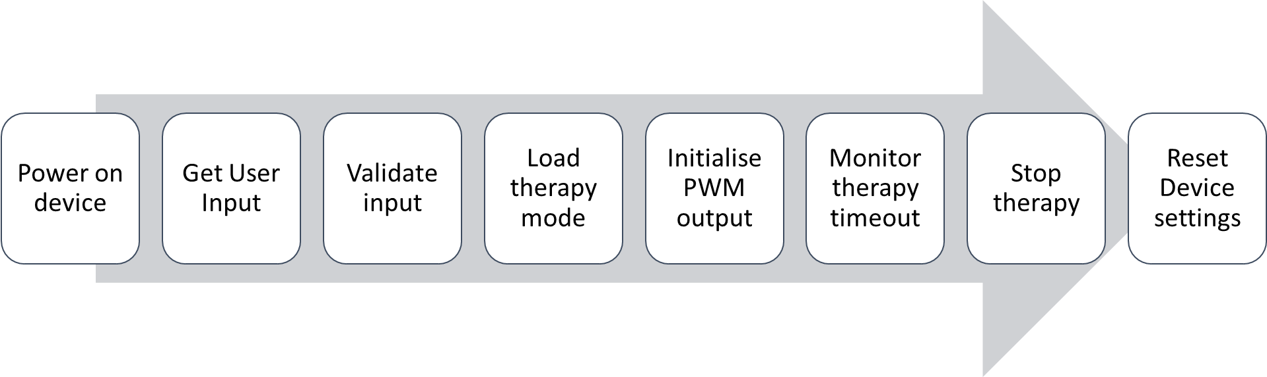

Figure 1: Vibration therapy working flow diagram

###### Thermotherapy

Thermotherapy is a therapy technique that involves the application of heat/cold to change the core temperature of soft tissues. It helps in pain relief, injury recovery and improved circulation. The main goal is to modify tissue temperature triggering therapeutic effects. Heat application affects the intra-articular and core tissue temperature helping in increased blood flow, accelerated metabolism, relief from muscle stiffness and joint pains. It is commonly used in musculoskeletal injury treatment and post-exercise recovery.

Types of thermotherapies:

* Heat Therapy: Uses warm compresses, heating pads and hot packs
* Cold Therapy: Uses ice packs, cold compresses or colling gels to reduce inflammation

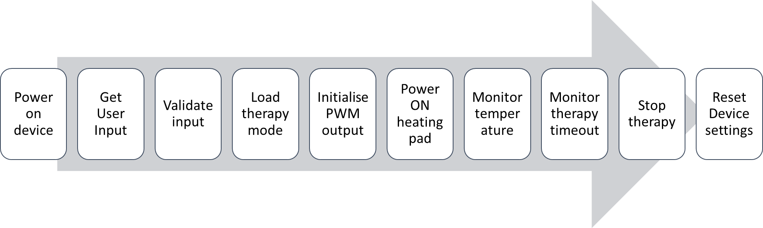

Figure 2: Thermotherapy working flow diagram

###### TENS Therapy

TENS is a non-invasive pain relief therapy that uses low-voltage electrical currents to stimulate nerves, altering pain perception. It is commonly used in physiotherapy and rehabilitation for both acute and chronic pain management. TENS therapy is drug free, non-invasive and safe. The pulse frequency can be customised according to user requirement. Additionally, battery-powered devices are portable and easy to use.

Small electrical pulses are delivered to or near the affected nerves using electrode pads placed on the skin. These pulses block pain signals from reaching the brain, reducing the sensation of pain. The electrical stimulation also triggers the release of endorphins, the body's natural painkillers, enhancing pain relief.

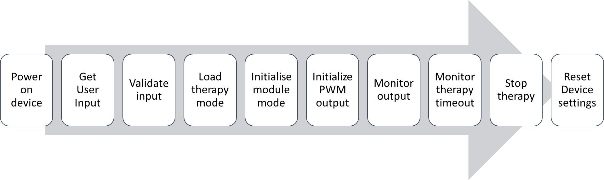

Figure 3: TENS Therapy working flow diagram

##### System Overview

###### Device Design Overview

This product integrates three different therapies used for physiotherapy – Vibration therapy, Thermotherapy and TENS therapy into a single portable unit. It is designed to be user-friendly allowing both clinical and individual use.

Key Design feature:

* Compact and Portable: Ergonomic design for easy use
* Rechargeable Battery: The estimated battery life is 2-3 hours per full charge
* Microcontroller Based control: Arduino Nano BLE33 manages therapy modes
* Device configuration: User can configure using physical buttons or mobile app

The developed prototype will be centrally controlled by Arduino Nano BLE33. It is powered using a 7.4 Volt rechargeable Li-ion battery that can provide 3 hours of device run-time in one full charge. There are buttons provided on the device for the user to configure the device in predefined modes. Additionally, the user can configure the therapy as required, using the mobile application. The configuration data will be communicated to the device via Bluetooth. The display shows the status of the device and the therapy modes selected by the user.

###### Microcontroller

A microcontroller is a compact integrated circuit designed to perform a specific function within an embedded system. It helps integrating and managing external peripherals connected in an embedded system. The Arduino Nano BLE33 is chosen as the core microcontroller for the physiotherapy device to control the modes of therapy as configured by the user. It is a development board with Bluetooth Low Energy (BLE) capabilities built on nRF52840 microcontroller. This enables wireless communication with the device helping users to configure device via Bluetooth using a mobile application.

Functionalities of Microcontroller:

* Manage therapy modes
* Control external peripherals
* Enable wireless communication with mobiles/tablets

###### Block Diagram

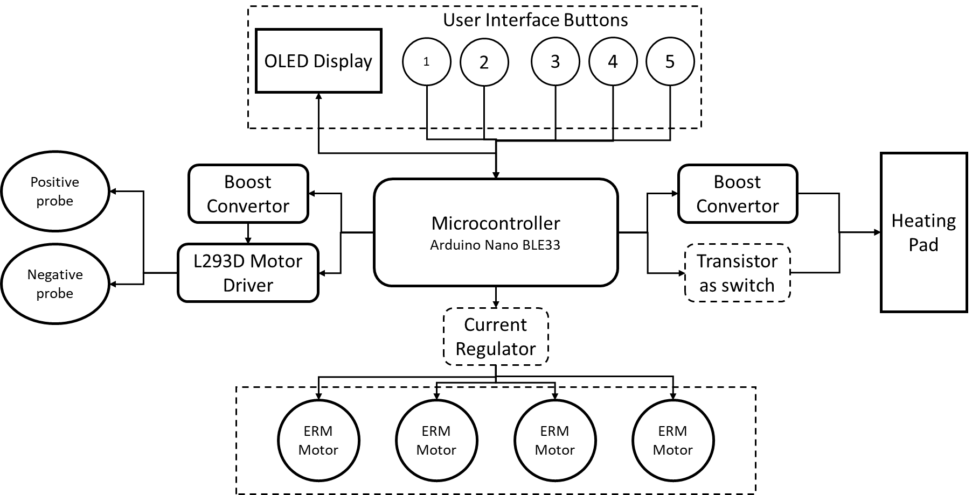

Figure 4: System Block Diagram

###### Bluetooth Low Energy (BLE)

BLE is a wireless communication protocol designed for low-power, short-range data transmission. It is mostly used in wearable devices and healthcare applications due to its energy efficient and fast connectivity. In the physiotherapy device, BLE communication is enabled for wireless control and configuration via mobile application.

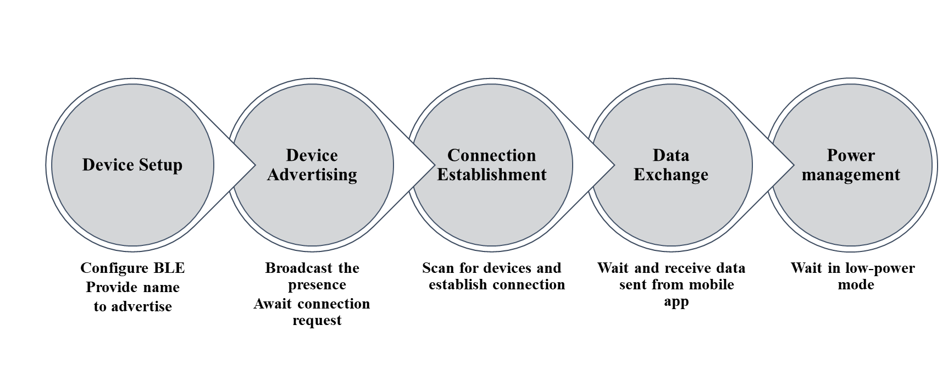

Figure 5: Bluetooth Communication and Data transfer steps

###### ERM Vibration Motors

Eccentric Rotating Mass (ERM) vibration motors are used in the devices to generate mechanical vibrations for vibration therapy. These motors create vibrations by rotating an offset mass, providing effective stimulation for muscle relaxation and pain relief. ERM motors contain small unbalanced weight attached to the rotor. When the motor rotates the unbalanced weight, the centrifugal force produces vibrations.

Motor Specifications:

* Operating voltage: 3.3V – 5V DC
* Input Current: 50mA to 100mA
* Frequency Range: 30Hz to 300Hz

The frequency of the vibration is controlled by PWM pins of the microcontroller. PWM output is adjusted based on the user configuration. A transistor acts as a switch and boosts current supply as motor current requirement is more than the current supplied via Arduino GPIO pins.

###### Heating Element

The heating element is responsible for delivering thermotherapy, which involves the application heat to relieve pain, enhance blood circulation and promote muscle relaxation. The system is designed to maintain a controlled temperature suitable for therapeutic applications. Heating pad converts electrical energy to heat energy. Power supply from battery is stepped up to 12 volts to power the heating element. The microcontroller monitors the temperature using a temperature sensor and maintains the required temperature by controlling the power supply using a transistor as a switch.

Heating element specification:

* Resistive heating pad
* Supply voltage: 12 Volt
* Max. Temperature: 70°C
* Control method: Transistor as switch

###### TENS Unit

TENS therapy involves the application of low-voltage electrical pulses to the skin via electrode pads. TENS unit is designed to generate biphasic pulse that are delivered to the body. The pulse width, frequency and duration of the therapy is controlled by the microcontroller PWM output based on user configuration. A DC-DC convertor s used to step-up voltage supply from the battery. A H-bridge based driver is used to invert the volage to produce a biphasic pulse. The biphasic output is delivered to the body via electrode pads placed on or near nerves. Current limiting MOSFETs are used to reduce the current delivered to the electrodes to avoid skin damages.

TENS Unit design specification:

* Pulse Generation: PWM output of microcontroller
* Voltage Regulation: XL6009 boost convertor
* Biphasic pulse generation: L293D motor driver

###### Integration and Device Architecture

The integration process for th physiotherapy device involves managing power distribution and signal control across three therapies. A 7.4 Volt battery serves as th main power supply, with buck-convertors and boost convertors regulating voltage as required.

* Vibration Therapy: LM7905 to step down voltage
* Thermotherapy: Boost convertor to raise voltage
* TENS Therapy: XL6009 step up convertor

Each therapy module is designed to work independently based on the user configuration. The microcontroller dynamically adjusts power output based on the requirements. The integration ensures the efficiency and safety in delivering therapy while optimizing battery life.

|  |  |
| --- | --- |
| Vibration Therapy | * Adequate current supply achieved using 2N2222 transistor * Battery voltage is stepped down to 5 Volt LM7905 regulator * Vibration intensity is controlled by PWM signal from microcontroller |
| Thermotherapy | * Battery voltage is stepped up to 12 Volt using a boost convertor * DHT sensor used for temperature feedback * Based on feedback data, microcontroller controls powering of Heating pad using a 2N2222 transistor. |
| TENS Therapy | * Required voltage is supplied through a Boost convertor. * Biphasic voltage generated using L293D H-Bridge. * H-Bridge signals sent from PWM pins of the microcontroller based on therapy configuration |

Table 1: Individual therapy module design

##### Hardware System Design

###### List of Components Used:

The physiotherapy device integrates various hardware components to enable vibration therapy, thermotherapy, and TENS therapy. The following table summarizes the key components and their functions:

|  |  |
| --- | --- |
| Component | Purpose |
| Arduino Nano BLE33 | Integrate, monitor and manage the therapies |
| 7.4 Volt Dual Cell Li-ion Battery | Rechargeable power supply for device |
| LM7805 Regulator | Step Down battery voltage for motors |
| ERM Vibration Motor | Produce mechanical vibration for therapy |
| 2N2222 Transistor | Current controlling device for vibration motors |
| 12 Volt Heating Element | Produce heat for thermotherapy |
| DHT Temperature sensor | Monitor temperature of heating element and provide feedback |
| XL6009 Boost Convertor | DC-DC Voltage to step up battery voltage for TENS |
| L293D H-Bridge | Generate biphasic pulse |
| IRF540N | Control current flow through TENS electrodes |
| OLED Display | Display device status and therapy modes |
| Buttons | Allow user input for therapy mode selection |

Table 2: List of components used to build prototype

###### Circuit Design

1. Power Supply and Voltage Regulation

The device is powered with a 7.4 Volt Li-ion battery. It is rechargeable and provides stable power supply for all components. The voltage output from the battery is regulated based on the requirements of each module.

* 5 Volt regulated output via LM7805 for vibration therapy
* 12 Volt regulated output via Boost convertor for heating pad
* 20 Volt – 35 Volt regulated supply via XL6009 for TENS unit

1. Vibration Therapy module

The Vibration therapy module is designed using Eccentric Rotating Mass vibration motors that generates mechanical vibration to stimulate the muscles. The ERM motors operate between 3.3 Volt to 5 Volt and the vibration intensity varies according to the voltage supply. Microcontroller’s PWM output is utilised to vary the supply voltage to control the vibration intensity. The module uses 2N2222 transistor, which acts as a switch to control current supply.

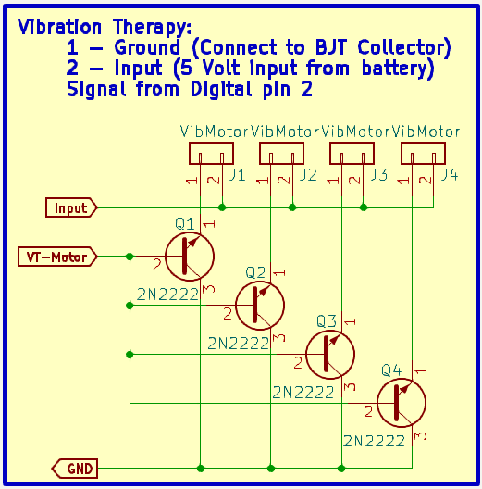

Figure 6: Vibration Therapy schematic

1. Thermotherapy module

The thermotherapy circuit is designed to apply controlled heat to relieve pain and improve blood flow. The 12 Volt heating element is powered via a boost convertor, which steps up the battery voltage. A DHT temperature sensor is used to monitor the temperature, providing real-time feedback to the microcontroller helping the controller to control the power supply and make decision to maintain user set temperature. The switching is done with the help of a 2N2222 transistor.

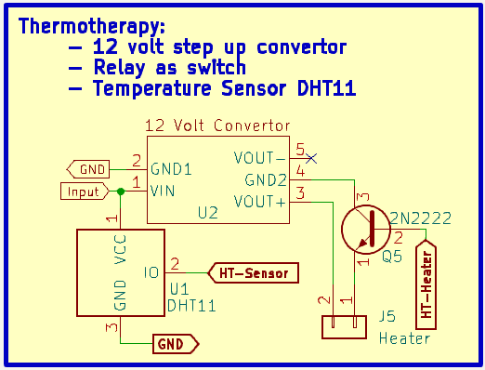

Figure 7: Thermotherapy schematic

1. TENS Therapy module

The TENS unit should deliver low-voltage pulses to the skin through electrode pads, stimulating the nerves to block pain signals reducing the perception of pain. Higher supply voltage is provided using XL6009 boost convertor. The L293D motor driver is used to generate biphasic pulses, ensuring the correct polarity of stimulation. The IRF540N MOSFET limit the current flow, preventing excessive stimulation and ensuring user safety. The PWM output from the microcontroller controls the pulse width, frequency and intensity based on user-defined therapy modes.

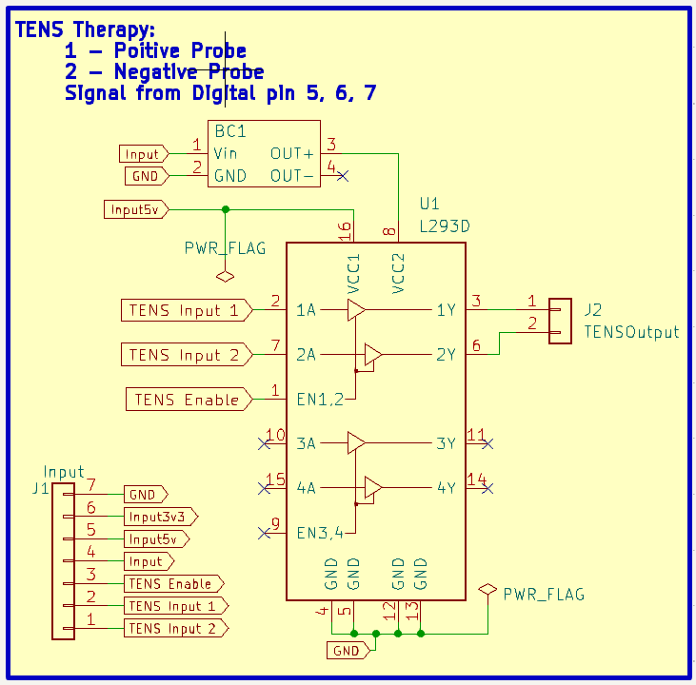

Figure 8: TENS Therapy schematic

1. User Interface

The UI of the physiotherapy device is designed to provide easy control and real-time feedback. It consists of an OLED display, Push button and Bluetooth enabled mobile application.

The OLED device with a resolution of 128 × 64 pixels (0.96 inches) provides real-time updates about the therapy enabled and the respective modes. Additionally gives information about the Bluetooth status and the battery power. Device status is communicated with the display using I2C communication protocol.

There are 5 control push button and 1 power button. The 5 buttons’ functionalities are as follows:

1. Start therapy once the user configures the therapy modes
2. Reset device or stop therapy in between the operation
3. Select a vibration mode among 3 in-built modes
4. Select a heating mode among 3 in-built modes
5. Select a tens mode among 3 in-built modes

These buttons provide a quick and reliable way to interact with the device when the user lacks access to the mobile application. The device is equipped with BLE, allowing users to control therapy modes via a mobile application. The mobile app enhances usability by offering a wireless alternative to physical buttons, making it easier for users to operate the device remotely and provides wider range of modes to configure the therapy.

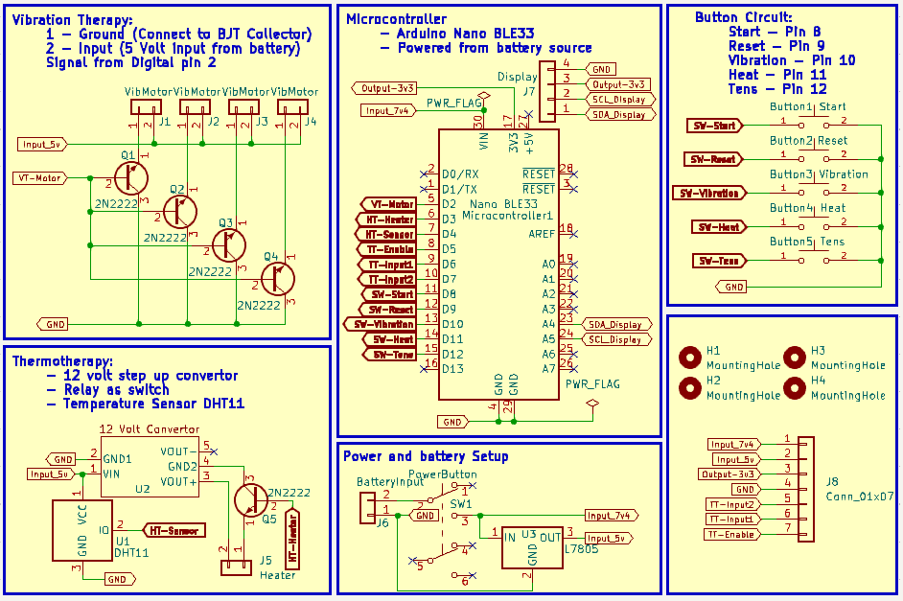

Figure 9: Overall System Schematic

##### Software Implementation

The software part of the product involves 2 major components, firmware for the microcontroller to monitor and control the therapy modules and the mobile application allowing user to configure therapy modes. The software components ensure the seamless working and communication between the hardware modules.

###### Firmware Development

The firmware is designed to efficiently control therapy modes and manage user input. It is developed using C programming in Arduino IDE and incorporates various mechanisms like hardware-interrupts, timer interrupts, managing debounce and data decoding.

Button press is detected using hardware interrupts. Interrupts help in providing instant response avoiding constant polling. This reduces power consumption and improves the device’s response. Mechanical push buttons can trigger multiple false presses during a single press by the user. To avoid this mechanical noise, software debouncing is implemented to ensure the buttons to return to stable state without disturbing other tasks. Periodic Timer Interrupt is used to monitor the device status, therapy mode, battery level and sensor feedbacks at regular intervals. Implementing this helps in avoiding frequent checking of device status which can disturb the smooth operation of the therapy.

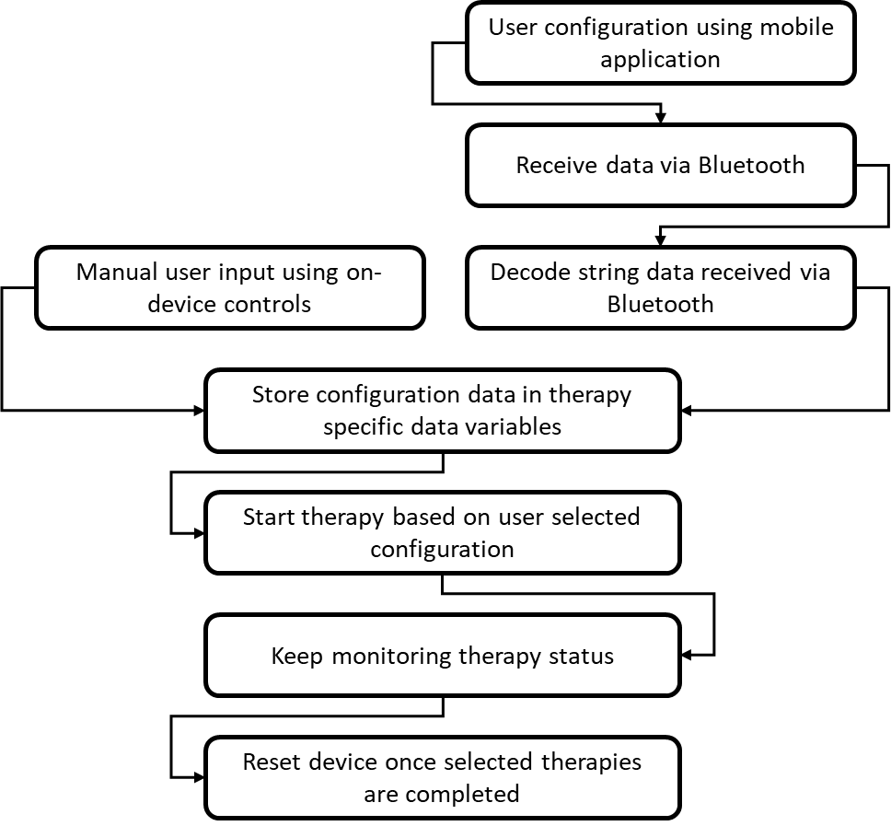

Figure 10: Steps of Firmware execution for device control

The data from mobile application is sent as a single encoded string via Bluetooth. The decoding of the string data and storing user configuration data in appropriate location for device monitoring is done by the microcontroller.

* OLED Display: Device status data sent via I2C protocol
* Vibration therapy: PWM signal triggered based on user selected intensity level
* Heat therapy: Digital pin used to switch the state of heating element
* TENS therapy: Control signals for motor driver is trigger based on user configuration

###### Mobile Application

The mobile application acts as the primary interface between the user and the device. Used to configure therapy modes and communicate with the physiotherapy device. It is developed using flutter and uses flutter_reactive_ble library for seamless Bluetooth connection with the device. The application can access and communicate with devices connected to the mobile using the BLE library. The app receives feedback message from the microcontroller to ensure error free communication and data transfer.

The first page of the application allows user to choose one or more therapies. Once the therapies are selected, the second page dynamically displays the configuration options only for the selected therapies. Based on the user configuration settings, the data is encoded as a single string not exceeding 40 bytes. The encoded string is then transmitted to the microcontroller via Bluetooth.

To further improve usability and user experience, the following features can be implemented in future updates:

* Implement session tracking, allowing user to track past therapy usage data. Store therapy data in local or cloud databases.
* Integrate with Machine Learning techniques to provide therapy usage suggestions for the user based on previous usage data logs.
* Add real-time data monitoring features to show live sensor data and device status in the application

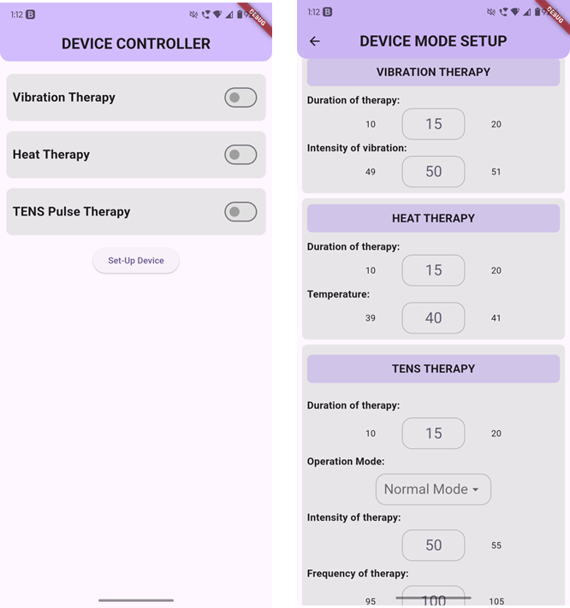

Figure 11: Mobile Application UI

##### PCB Design and Fabrication

Printed Circuit Board Design is the process of physically realizing an electronic circuit by laying out components and routing the electrical connection between them on a flat board made of insulating material and copper layers.

|  |  |  |  |  |
| --- | --- | --- | --- | --- |
| Type | Layers | Use Case | Advantages | Disadvantages |
| Single layer | 1 | Simple circuits and toys | Low Cost  Easy to design | Limited Complexity |
| Double Layer | 2 | Consumer Electronics | More routing space | Higher Cost |
| Multi-Layer | 4+ | Smartphones | High Density  EMI Control | Expensive  Hard to test |

Table 3: Types of PCB based on layers

###### Objectives of PCB Design:

* Provide mechanical support and electrical connections for components.
* Minimize noise, power loss, and interference.
* Ensure reliability, compactness, and serviceability.

###### Advantages of Double Layered PCB:

* Components can be arranged efficiently, reducing weight and size of device
* Device routing can be done easily by splitting traces between top and bottom layers
* Fixed connections avoid human error and loose connections
* Ease of testing and maintenance
* Simplified and clean design simplifies troubleshooting
* Automated fabrication and soldering speeds up manufacturing in large scale

Figure 12: Steps in PCB Design and Fabrication

The physiotherapy device includes 2 custom-designed PCB’s. The PCBs are designed to optimise space, ensure proper electrical connection and safety of the user.

The top PCB is the primary control board mounted on the top of the device consisting buttons and displays. It is designed as a two-layered PCB for efficient routing of signals and power. It handles the primary tasks like user interface and power management and contains the microcontroller, vibration module and thermotherapy module.

The bottom PCB is mainly designed for TENS therapy module. The signals for TENS from the microcontroller will be routed to the bottom board using physical wires. It provides isolated and controlled stimulation. Helps to reduce the size of the device ensuing user-friendly design and portability.

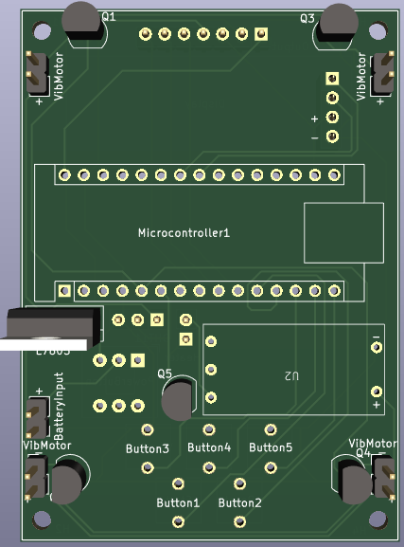

Figure 13: PCB 1 Top Side

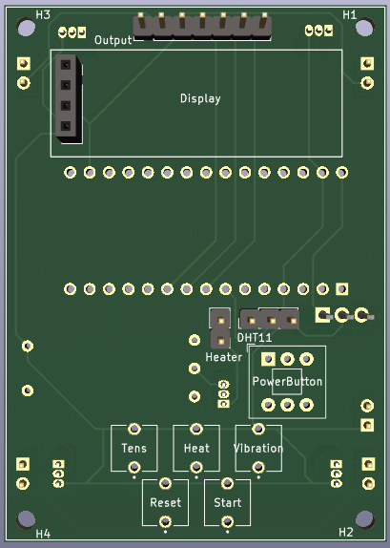

Figure 14: PCB 1 Bottom Side

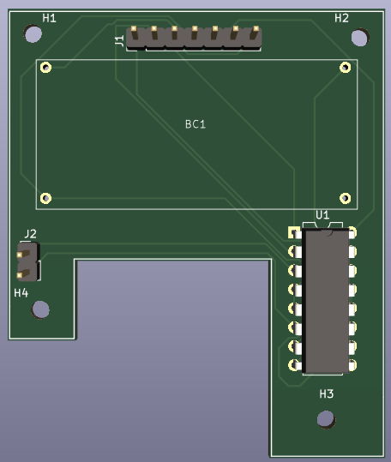

Figure 15:PCB 2 Top Side

##### Device Packaging

The enclosure of the physiotherapy device is designed to hold the PCBs battery and the external interface components. The casing is designed ensuring the ease of access to the buttons, charging ports and the output port of TENS.

Figure 16: Steps in 3D Printing

Design Considerations:

* Stacked PCB
* Accessibility of buttons
* Visibility of OLED display
* Battery placement

The device package is designed using software keeping in mind the design requirements and constraints. The developed design is 3D printed and the components are assembled as planned. The final design of the product will be compact, portable and ergonomic.

## Chapter 4

# Results and Declaration

##### Objectives

The product aims to provide portable, battery-powered solution for muscle and nerve stimulation by integrating Vibration therapy, Thermotherapy and TENS therapy. The key objectives include:

* Comprehensive physiotherapy solution
* User-friendly and ergonomic design
* Adjustable and user-configurable therapy modes
* Wireless device configuration control
* Supports professional and personal use

The main requirements identified for the device focus on compact and portable design supporting multiple therapies. The device must comply with medical safety standards while providing an efficient and compliant solution for both professional and personal use. Additionally, Bluetooth-enabled mobile application should allow users to easily configure therapy modes.

##### System Performance and Validation

The developed physiotherapy device was evaluated based on its functional accuracy, system stability, and power efficiency. The testing process involved validating therapy activation, user interface responsiveness, and power management.

Each therapy module—Vibration Therapy, Thermotherapy, and TENS Therapy—was tested independently to ensure proper operation. The vibration module was evaluated for speed variation using PWM control, and the response was validated. The thermotherapy unit was tested using a temperature sensor to verify that the heating pad reached and maintained the set temperature within an acceptable margin. The TENS therapy circuit was analysed using an oscilloscope to confirm proper biphasic pulse generation and safe current limits.

The user interface was validated through multiple trials, ensuring that button presses were detected correctly without debounce errors, and that the OLED display provided real-time feedback on therapy modes and system status. The Bluetooth module was tested by establishing multiple connections between the mobile application and the device, verifying that therapy commands were reliably transmitted and executed.

##### Constraints and Challenges

During the development of the physiotherapy device, several constraints and challenges were encountered. These challenges primarily revolved around power management, PCB design complexity, Bluetooth Low Energy (BLE) connectivity, and data transfer reliability.

###### Power management

Since the device operates on a 7.4V Li-ion battery, efficient power distribution and regulation were critical. The following challenges were addressed:

**Multiple Voltage Requirements:** The system required 12V for the heating pad, 5V for control circuitry, and variable voltages for vibration and TENS therapy. This necessitated the use of multiple buck and boost converters (LM7905, XL6009, etc.), which introduced concerns related to heat dissipation and efficiency.

**Power Optimization:** Continuous power drain due to active therapy modules required implementing low-power standby modes when therapies were not in use. This helped in improving battery life while ensuring quick wake-up response when therapy was reactivated.

###### Bluetooth Connectivity and Data transfer

The mobile application, developed in Flutter using the flutter_reactive_ble library, encountered two major BLE-related challenges:

**Defining Maximum Data Transfer Packet Size:** Initially, the BLE communication was restricted to a default 20-byte packet size, which limited the amount of data that could be transmitted in a single message. After identifying this issue, the maximum packet size was increased to 40 bytes, allowing larger data transfers per transmission. This optimization reduced the number of packets required for sending therapy configurations, improving efficiency and lowering transmission latency.

**Re-pairing Required on Every Use:** The Bluetooth MAC address of the device changed on every power cycle, requiring users to pair the device as a new device each time it was used. This was due to the absence of a fixed static address, which made automatic reconnection difficult. To mitigate this issue, the mobile app scanned for specific BLE service UUIDs instead of relying on MAC addresses, enabling automatic detection of the correct device.

##### Project Timeline and Milestones

The development of the proposed physiotherapy device was done in well-defined phases, each focusing on the technical aspects. The below image represents the defined work flow of the development.

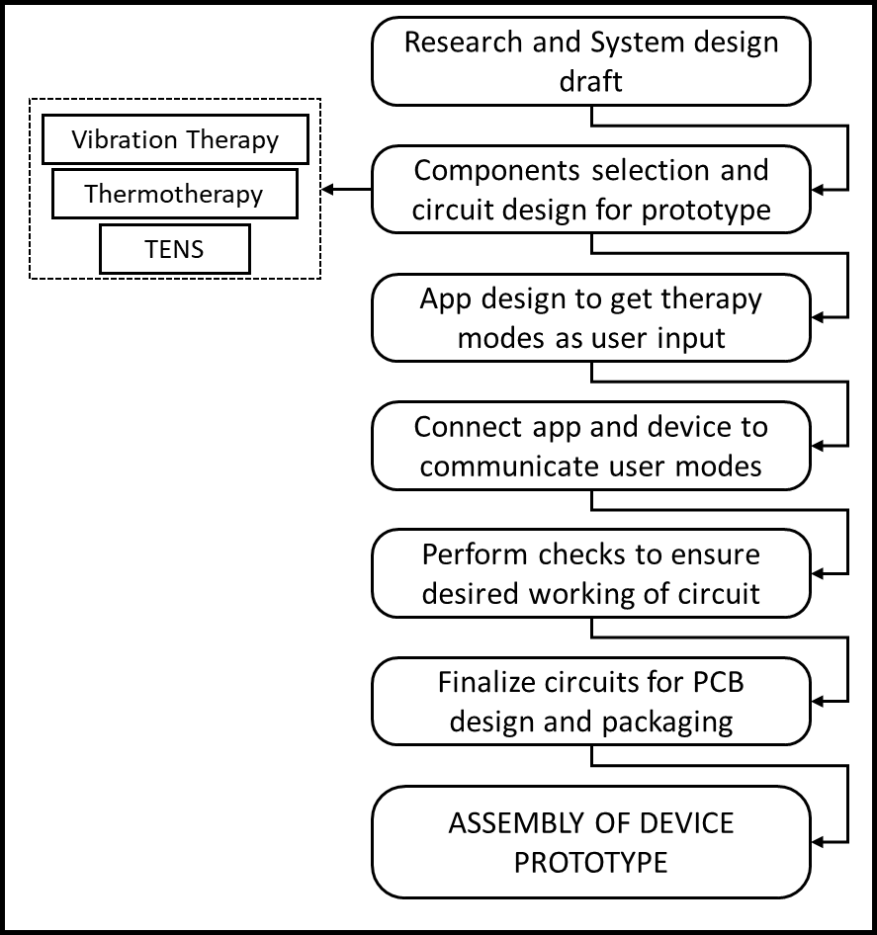

Figure 17: Overall project workflow

This flow chart shows the iterative approach followed during the design and implementation of the physiotherapy device. It heled to maintain clarity in task distribution, ensured timely debugging and facilitated progressive feature integration.

## Chapter 5

# Conclusion and Future Work

##### Conclusion

The developed physiotherapy device successfully integrates Vibration therapy, Thermotherapy and TENS therapy into a single portable unit. The key challenges identified during the development has been addressed to ensure a functional and user-friendly product.

The developed prototype provides,

* Wireless therapy configuration via flutter-based mobile application
* Stable power management with efficient use of buck and boost convertors
* Optimised BLE communication
* Compact and ergonomic design integrating 2 stacked PCB and battery pack

The physiotherapy device meets the initial design objectives address the requirements of individual users.

##### Future Work

To further enhance the prototype the following improvements can be planned,

1. **Firmware Optimisation:**

Improve power efficiency with better sleep/wake cycles and idle time power management techniques. Reduce processing delays and optimising BLE connection stability ensuring faster pairing.

1. **Hardware Enhancement:**

Develop a more compact version by optimising PCB layout, optimise power utilisation to improve battery life and reducing battery size.

1. **Mobile Application Upgrade:**

Enhance user interface and make it more informative by adding real-time information about the device working and the status of the device. Provide recommendations from results of ML based analysis about therapy usage.

1. **ML based therapy Recommendation:**

Prepare cloud-based database to store therapy usage pattern of individual users. Analyse the user data, identify therapy patterns over time and provide personalised therapy modes recommendation. Use the user data to optimise therapy intensity and duration dynamically.

Figure 18: Future device enhancement and optimisation ideas

## Chapter 6

# Appendix

##### Firmware Code

###### Hardware and Timer interrupt declaration

attachInterrupt(digitalPinToInterrupt(STARTBUTTONGPIO), startTherapy, FALLING);

attachInterrupt(digitalPinToInterrupt(RESETBUTTONGPIO), resetDevice, FALLING);

attachInterrupt(digitalPinToInterrupt(VIBRATIONBUTTONGPIO), vibrationModeChange, FALLING);

 attachInterrupt(digitalPinToInterrupt(HEATBUTTONGPIO), heatModeChange, FALLING);

attachInterrupt(digitalPinToInterrupt(TENSBUTTONGPIO), tensModeChange, FALLING);

interruptTimer.setInterval(1000000, timerInterruptHandler);

###### Button press and Debounce check:

void tensModeChange() {

  unsigned long buttonPressTime = millis();

  if(buttonPressTime - prevInterruptTime > debounceDelay) {

    tensMode++;

    prevInterruptTime = buttonPressTime;

  }

  if(tensMode == 3) {

    tensMode = tensMode%3;

  }

  if(tensMode != 0) {

    tens = true;

  }

  else {

    tens = false;

  }

}

###### Bluetooth communication Setup and data decoding

int indexCount = 0;

String deviceData = "";

String decodedConfigData[11];

BLEService customServiceUuid("12345678-1234-5678-1234-56789abcdef0");

BLEStringCharacteristic deviceCharacteristic("abcdef01-1234-5678-1234-56789abcdef0", BLEWrite, 40);

BLEDevice central;

bool bleConnected = false;

if (!BLE.begin()) {

    Serial.println("Failed to initialize BLE!");

    while (1);

  }

  BLE.setLocalName("Therapy Device");

  BLE.setAdvertisedService(customServiceUuid);

  customServiceUuid.addCharacteristic(deviceCharacteristic);

  BLE.addService(customServiceUuid);

  BLE.setConnectionInterval(40, 80);

  BLE.advertise();

  Serial.println("BLE device is now advertising as 'therapy device'");

void getBluetoothData() {

  central = BLE.central();

  if (central.connected()) {

    if (deviceCharacteristic.written()) {

      deviceData = deviceCharacteristic.value();

      Serial.print("Received: ");

      Serial.println(deviceData);

      decodeData();

    }

  }

}

void decodeData() {

  String receivedData = deviceData;

  int start = 0;

  int index = 0;

  while ((index = receivedData.indexOf('/', start)) != -1) {

    String temp = receivedData.substring(start, index);

    decodedConfigData[indexCount] = temp;

    start = index + 1;

    indexCount++;

  }

  decodedConfigData[indexCount] = receivedData.substring(start);

  if(decodedConfigData[0] == "true") {

    vibration = true;

    vibrationMode = -1;

    vibrationDuration = decodedConfigData[1].toInt();

    vibrationDuration = vibrationDuration*1000;

    vibrationIntensity = decodedConfigData[2].toInt();

  }

  Else {

    vibration = false;

  }

  if(decodedConfigData[3] == "true") {

    heat = true;

    heatMode = -1;

    heatDuration = decodedConfigData[4].toInt();

    heatDuration = heatDuration*1000;

    heatTemperature = decodedConfigData[5].toInt();

  }

  else {

    heat = false;

  }

  if(decodedConfigData[6] == "true") {

    tens = true;

    tensMode = -1;

    tensDuration = decodedConfigData[7].toInt();

    tensDuration = tensDuration*60*1000;

    tensMode = decodedConfigData[8].toInt();

    tensFrequency = decodedConfigData[9].toInt();

    tensIntensity = decodedConfigData[10].toInt();

  }

  else {

    tens = false;

  }

  bluetoothDataStatus = true;

}

###### Timmer Interrupt to check device status

void timerInterruptHandler() {

  if(deviceRunningStatus) {

    timerInterruptCount++;

    if(vibration) {

      if(timerInterruptCount - vibrationTimerStartCount >= vibrationDuration) {

        stopVibration();

      }

    }

    if(heat) {

      if(timerInterruptCount - heatTimerStartCount >= heatDuration) {

        stopHeat();

      }

    }

    if(tens) {

      if(timerInterruptCount - tensTimerStartCount >= tensDuration) {

        stopTens();

      }

    }

  }

}

###### Device status display

void displayDeviceStatus() {

  display.clearDisplay();

  display.setTextSize(1);

  display.setTextColor(WHITE);

  if(!vibration && !heat && !tens) {

    display.setCursor(0, 0);

    display.print("Therapy Device");

    display.setCursor(0, 10);

    display.print("Select Therapy");

  }

  if(BLE.connected()) {

    display.setCursor(95, 0);

    display.print("Con");

  }

  Else {

    display.setCursor(90, 0);

    display.print("Dis");

  }

  if(vibration) {

    display.setCursor(0, 10);

    display.print("Vib");

    display.setCursor(0, 20);

    display.print("Mode: ");

    display.setCursor(25, 20);

    if(vibrationMode == -1) {

      display.print("B");

    }

    Else {

      display.print(vibrationMode);

    }

  }

  if(heat) {

    display.setCursor(40, 10);

    display.print("Heat");

    display.setCursor(40, 20);

    display.print("Mode: ");

    display.setCursor(65, 20);

    if(heatMode == -1) {

      display.print("B");

    }

    Else {

      display.print(heatMode);

    }

  }

  if(tens) {

    display.setCursor(80, 10);

    display.print("TENS");

    display.setCursor(80, 20);

    display.print("Mode: ");

    display.setCursor(105, 20);

    if(tensMode == -1) {

      display.print("B");

    }

    else {

      display.print(tensMode);

    }

  }

  display.display();

}

##### Flutter Application Development Code

###### Bluetooth Setup and data encoding

class _SetupPage extends State<SetupPage> {

  final FlutterReactiveBle flutterReactiveBle = FlutterReactiveBle();

  final Uuid serviceUuid = Uuid.parse(

      "12345678-1234-5678-1234-56789abcdef0"); // Replace with actual service UUID

  final Uuid characteristicUuid = Uuid.parse(

      "abcdef01-1234-5678-1234-56789abcdef0"); // Replace with actual characteristic UUID

  String deviceId =

      "11:C1:90:B3:8E:AC"; // Replace with the connected device's ID

  late QualifiedCharacteristic characteristic;

  int vibration = 0;

  int heat = 0;

  int tens = 0;

  int _currentVibrationIntensityValue = 50;

  int _currentVibrationDurationValue = 15;

  int _currentTemperatureValue = 40;

  int _currentHeatDurationValue = 15;

  int _currentTensDurationValue = 15;

  int _currentTensMode = 1;

  int _currentTensFrequency = 100;

  int _currentTensDIntensityValue = 50;

  String data = "";

  @override

  void initState() {

    super.initState();

    characteristic = QualifiedCharacteristic(

      characteristicId: characteristicUuid,

      serviceId: serviceUuid,

      deviceId: deviceId,

    );

  }

  void makeString() {

    data = "";

    if (widget.vibrationStatus) {

      data = "true";

      data = "$data/$_currentVibrationDurationValue";

      data = "$data/$_currentVibrationIntensityValue";

    } else {

      data = "false/0/0";

    }

    if (widget.heatStatus) {

      data = "$data/true";

      data = "$data/$_currentHeatDurationValue";

      data = "$data/$_currentTemperatureValue";

    } else {

      data = "$data/false/0/0";

    }

    if (widget.tensStatus) {

      data = "$data/true";

      data = "$data/$_currentTensDurationValue";

      data = "$data/$_currentTensMode";

      data = "$data/$_currentTensFrequency";

      data = "$data/$_currentTensDIntensityValue";

    } else {

      data = "$data/false/0/0/0/0";

    }

    sendData(data);

    print(data);

  }

# Bibliography

1. M. Ghazi, J. Rippetoe, R. Chandrashekhar, and H. Wang, “Focal Vibration therapy: Vibration parameters of effective wearable devices,” *Applied Sciences*, vol. 11, no. 7, p. 2969, Mar. 2021, doi: 10.3390/app11072969.
2. Adilkhanov, M. Rubagotti, and Z. Kappassov, “Haptic Devices: Wearability-Based Taxonomy and Literature Review,” *IEEE Access*, vol. 10, pp. 91923–91947, Jan. 2022, doi: 10.1109/access.2022.3202986.
3. Abbasimoshaei, D. Laatz, and T. A. Kern, “Developing a new focal vibration and heat therapy system,” *Current Directions in Biomedical Engineering*, vol. 9, no. 1, pp. 101–104, Sep. 2023, doi: 10.1515/cdbme-2023-1026.
4. Sonwane, C. Y. Patil, and G. Deshmukh, “Design and Development of Portable Transcutaneous Electrical Nerve Stimulation Device and Basic Principles for the use of TENS,” *2018 2nd International Conference on Trends in Electronics and Informatics (ICOEI)*, pp. 285–287, May 2018, doi: 10.1109/icoei.2018.8553898.
5. N. A. Z. Sulaiman, A. A. Ibrahim, and M. H. M. Zaman, “A programmable transcutaneous electrical nerve stimulation device based on arduino and remote control using a smartphone,” *International Journal of Advanced Technology and Engineering Exploration*, vol. 8, no. 75, pp. 320–327, Feb. 2021, doi: 10.19101/ijatee.2020.762149.
6. M. Alam, “An easy-to-build transcutaneous electrical stimulator for spinal cord stimulation therapy,” *Research Square (Research Square)*, Oct. 2022, doi: 10.21203/rs.3.rs-2116817/v1.
7. S. Sarkar, “Design of transcutaneous electrical nerve stimulating machine using 555 timer and 7555 timer,” *International Journal of Science and Research (IJSR)*, vol. 5, no. 12, pp. 1043–1049, Nov. 2016, doi: 10.21275/art20162812.

# Biodata

Name : Achyut Narayan H

Mobile No. : 9176780191

E-mail : achyutnarayan.h2021@vitstudent.ac.in

Permanent Address :

Villa 19 Phase 3, Jones Cassia,

Karanai main road, Ottiyambakkam,

Chennai – 600130.